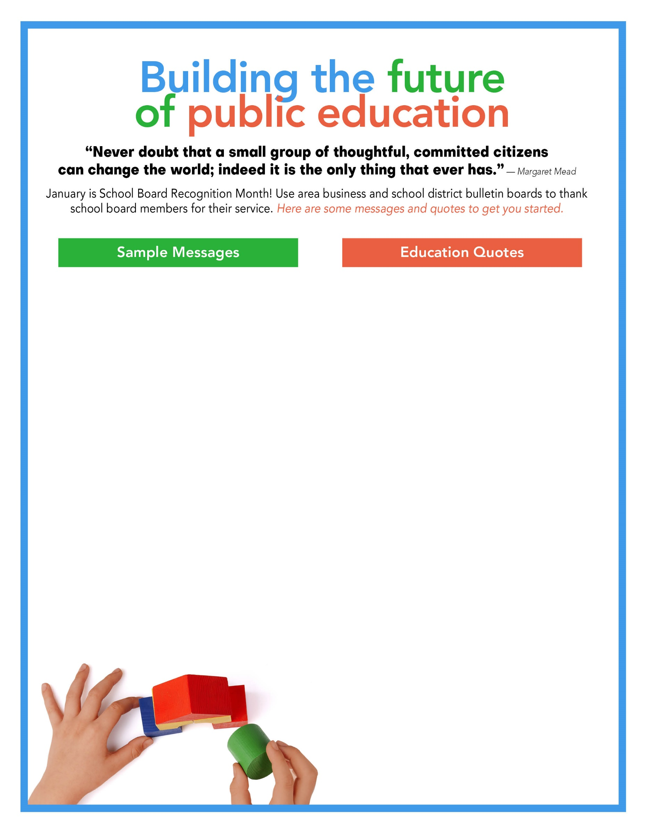

January is School Board Recognition Month

Say “Thank you!”

Helping kids soar to Success!

School Board Recognition Month

Superheroes for schools

Thank you, school board!

School boards make a powerful difference

School boards lead so students achieve

Positive, supportive, caring

Thank you, school board members!

Strong schools = Strong communities

Thank your school board

Leading students to success

____________ School Board

____________ School Board

Working to make a difference

“The Public School is the cornerstone of a democratic society.”*—Horace Mann*

“Education is not preparation for life;

education is life itself.”*—John Dewey*

“An investment in knowledge pays the

best interest.” *—Benjamin Franklin*

“Education is not the filling of a pail, but

the lighting of a fire.” *—William Butler Yeats*

“The beautiful thing about learning is that no one can take it away from you.” *—B.B. King*

“I am still learning.”*— Michelangelo*

“The more that you read, the more

things you will know. The more that you

learn, the more places you’ll go.” *― Dr. Seuss*

“Learning never exhausts the mind.”

*― Leonardo da Vinci*

“Learning is a treasure that will follow

its owner everywhere.” *— Chinese Proverb*

A mind, once stretched by a new idea, never regains its original dimensions.

*—Oliver Wendell Holmes, Jr.*

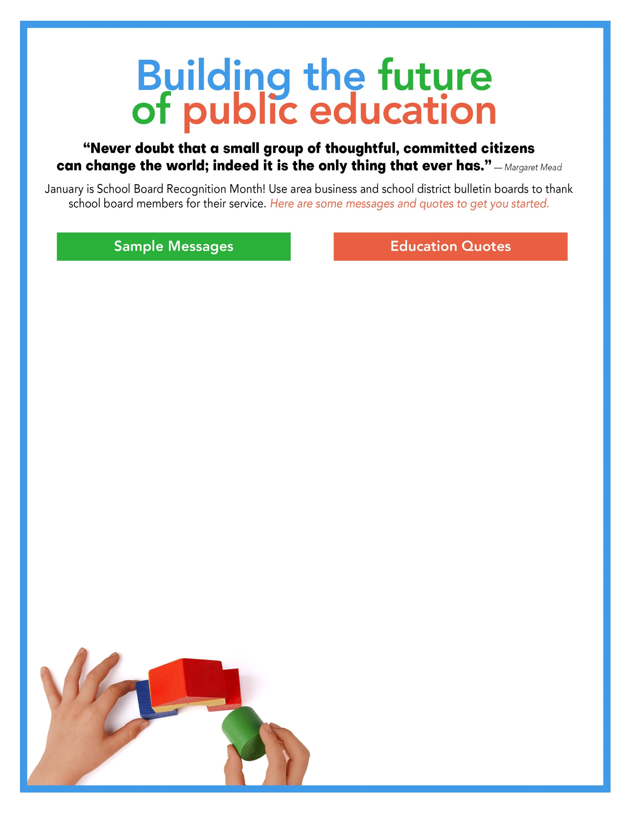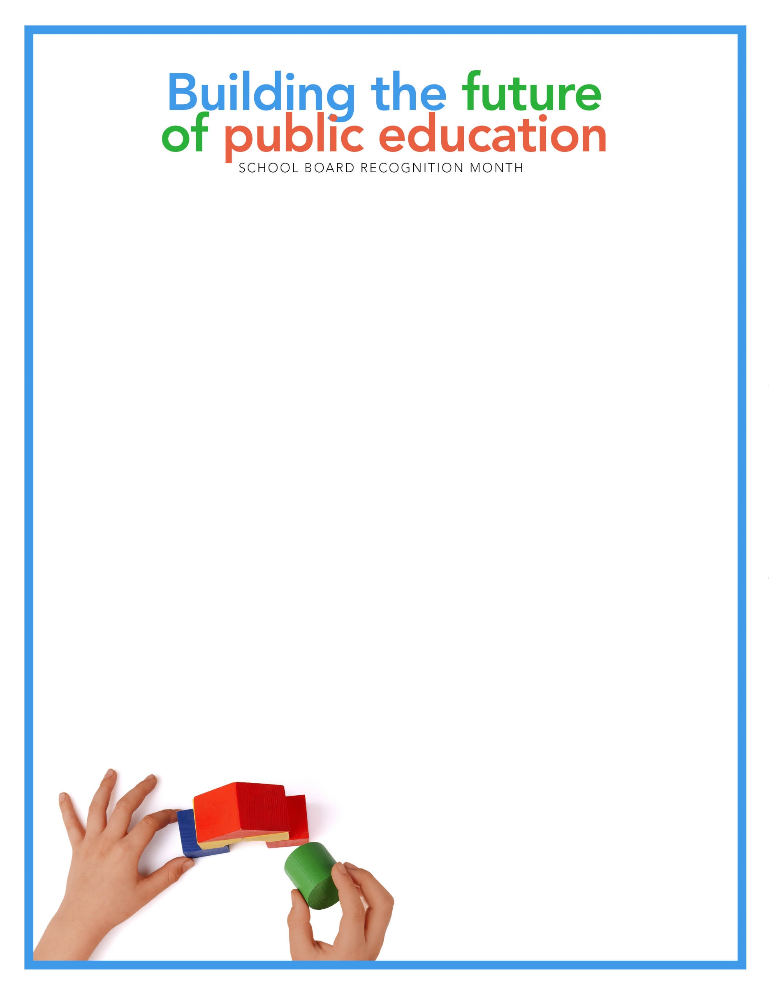

Insert your quote here

Insert your board’s photo here